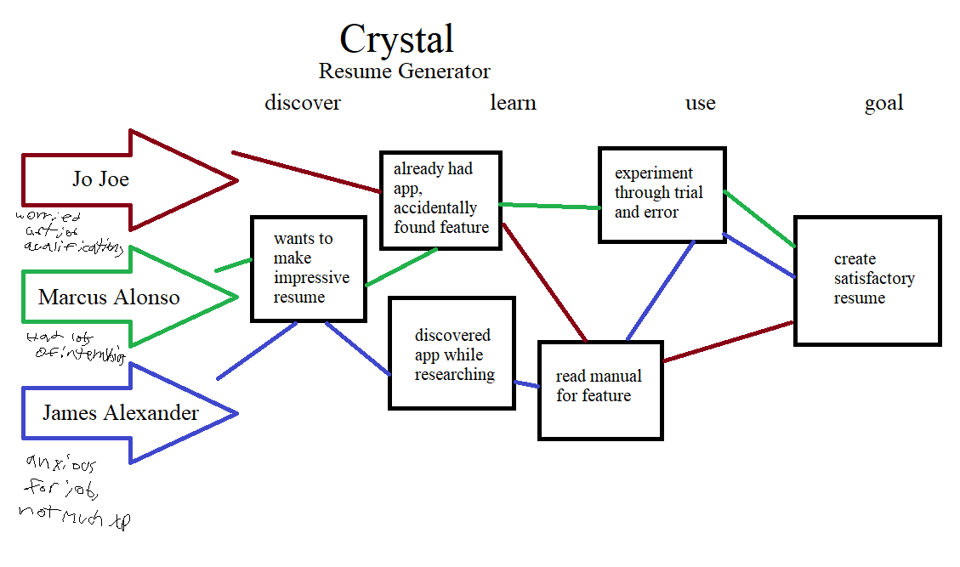

Scenario: Perfect resume

As a user, I want to create a resume perfectly tailored for a specific job

User stories

Marcus Alonso

As a junior in college with impressive internships, I want a resume generator to help me display my internships while job-hunting

James Alexander

As a senior in college, I want a resume generator so I can make a resume that will maximize my chances of success at job-hunting despite having little job experience

Jo Joe

As a senior in college, I want a resume generator so I can create a resume I know will help me get a job in the field I want

Feature List

1. Ability to input information about internships or other job experience

2. Ability to input coursework/education information

3. Ability to tailor resume for specific job listing or industry